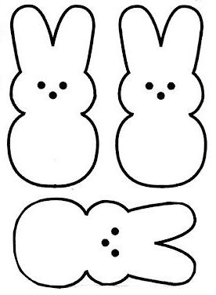

For PEEPS sake,

Drop Everything and Read!

For PEEPS sake,

Drop Everything and Read!

For PEEPS sake,

Drop Everything and Read!